Analysis protocol

# Learning network complexity through gameplay: Part B. Analysing player actions

2021

*Authors:*

Chris Moreno-Stokoe, Claire Haworth & Oliver Davis

Contents

## Background

## Introduction

## Aims & Objectives

## Methods

## Design

## Participants

## Materials

## Procedure

## Data analysis plan

## Inventory of data

## Data cleaning

## Scoring

## Planned analyses

# Background

# Introduction

Chapter 4 detailed the design and development of *Mendel*, a knowledge game which fully integrates the problem of intervention making in the complex network of human health. In this game:

1. Players played an intervention simulation game
2. Players learned about a public health network
3. Players offered solutions to public health scenarios during gameplay

Chapter 5a experimentally investigated the player experience and learning outcomes from *Mendel*. Chapter 5b will investigate the value of knowledge contributions offered by players during gameplay.

Chapter 5a did not reveal significant learning improvements for players compared with a an interactive visualisation control. However, the multiple-choice questionnaire assessment may not have captured over-time learning. Players of the game may have learned to better design interventions through the course of their gameplay. This is due to the concrete experiences and active experimentation which knowledge games afford (Ricardi & DePaulis, 2014). Since *Mendel* anonymously records player data this can be directly measured by tracking players’ intervention effectiveness over time. Players who successfully apply information to suggest effective intervention solutions can be said to have achieved a higher understanding of public health (e.g., Bloom’s Taxonomy of Learning: Anderson & Bloom, 2001).

Furthermore, investigating player actions is of further value since players suggested solutions to public health problems. Simulation games can realistically model phenomena to the degree that players can offer real-life solutions to problems (Bilson, Bekebrede & Mayer, 2010; Guerts et al., 2007). As humans, players will offer solution based on their own reasoning, perspectives and biases rather than computing the mathematically optimal solution. Players’ solutions were compared to a computer algorithm’s determination of the mathematically optimal solution to each problem which is unbiased but can cannot reason so often offers impractical solutions. Humans will take into account factors beyond maths and so may result in different solutions to computers. Combining the reasoning strengths of humans with mathematical accuracy of computers may help arrive at effective and practical interventions.

# Aims

##### Research question

What can be learned from analysing players’ actions in a public health intervention simulation game?

##### Objectives

Player actions will be investigated to test the following hypotheses:

1. Players will learn to design more effective interventions over-time
2. Humans will make different interventions to computers

Furthermore we will explore the network properties which contribute to complexity and decision making in the simulation

# Methods

## Design and participants

In Chapter 5a, participants in the game condition (n=90) had their in-game actions anonymously recorded. Players made 2255 interventions. This data is analysed in this study separate to the questionnaire data collected in Chapter 5a which it cannot be linked to.

Ethics approval was obtained from the University of Bristol Psychological Science School Research Ethics Committee (ID: 111083).

## Procedure

Participants played *Mendel* (Fig 1) and through the course of gameplay offered intervention solutions to public health problems. Players were given an objective (e.g., raise wellbeing) and a selection of traits to intervene on in order to achieve it. When players made interventions data was recorded including an anonymous ID unique to their play session, a timestamp, what their objective was and what intervention they suggested. This data was delivered from the JavaScript client using an XML HTTP request to a PHP script which stored data to a database using pre-prepared SQL statements. Once stored, data was ready in CSV format.

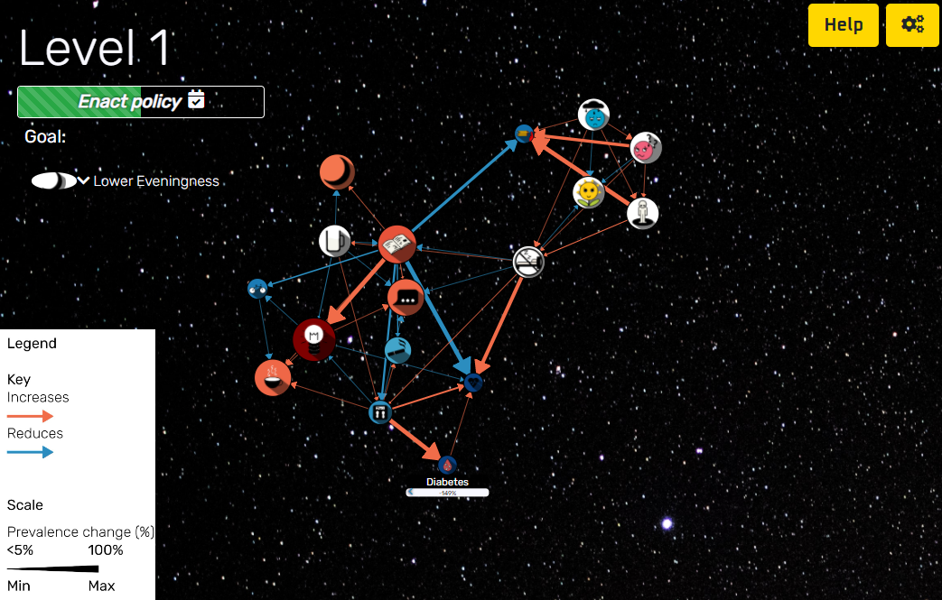

Figure 1. Screenshot from Mendel: <https://www.morenostok.io/mendel/game.html>

# Analysis plan

# Data cleaning

Pilot data will be removed by removing entries from before the study was launched to participants (16th December). Since player data is anonymous individuals cannot be excluded on an individual basis in the same way as in Chapter 5a.

# Scoring

As in Chapter 5a, players’ interventions received scores expressed as a percentage of the optimal intervention. Interventions received both an objective score and side-effect score.

# Data joining

Data from participants will be enriched with properties and network characteristics. This will provide more information to better describe and analyse players’ actions. For each player action three categories of information are recorded:

* Information on the player (Table 1: Player information)
* The problem the player was trying to solve with an intervention (Table 2: Problem characteristics)
* Properties of the trait the player chose to intervene on (Table 3: Trait characteristics)
* Network properties of the intervention (Table 4: Intervention characteristics)

**Table 1**. Player information

|  |  |
| --- | --- |
| **Unique User ID** | **Timestamp** |
|  |  |

**Table 2**. Problem characteristics

|  |  |  |
| --- | --- | --- |
| **Objective trait** | **Maximum number of permitted interventions** | **Current number of interventions** |
|  |  |  |

**Table 3**. Trait characteristics

|  |  |  |  |  |  |  |  |
| --- | --- | --- | --- | --- | --- | --- | --- |
| **Trait intervened on** | **Valence** | **N Predecessors** | **N Successors** |  | **Centrality (eigenvalue)** |  |  |
|  |  |  |  |  |  |  |  |

**Table 4**. Intervention characteristics

|  |  |  |  |  |  |
| --- | --- | --- | --- | --- | --- |
| **Trait intervened on** | **Score (objective)** | **Score (side-effect)** | **Total n effects** | **Effects (on each traits)** | **Paths to each trait (length)** |
|  |  |  |  |  |  |

# Analysis

###### Hypothesis testing

While the accepted alpha level will be 0.05, this will not be used as a strict requirement, and instead this will be evaluated in the context of the magnitude of effect size as well (this following IEU guidelines on significance thresholds). A hypothesis will be rejected if all its tests return non-significant results by this criteria.

The hypotheses will be tested as follows:

1. Players will learn to design more effective interventions over-time
   * Within each participant their interventions will be assigned ranks to denote the order in which they were made. Time ranks will then be correlated against the score these interventions received (objective score & side-score)
2. Humans will make different interventions to computers
   * The most popular interventions made by humans and computers will be described
   * Human and computer-made interventions will be described and t-tested for differences in:
     + - Objective score (effect on objective trait)
       - Side-effect score (goodness of side effects)
       - Valence (good/bad traits)
       - Network properties

###### Exploratory analysis

Using the data above the network properties which contribute to complexity and decision making in the simulation will be investigated by matrix correlation and investigating the properties of the most popular interventions made by computers and humans.

# References

Anderson, L. W., Bloom, B. S., & others. (2001). *A taxonomy for learning, teaching, and assessing: A revision of Bloom’s taxonomy of educational objectives*. Longman,.

Geurts, J. L. A., Duke, R. D., & Vermeulen, P. A. M. (2007). Policy Gaming for Strategy and Change. *Long Range Planning*, *40*(6), 535–558. https://doi.org/10.1016/j.lrp.2007.07.004

Ricciardi, F., & De Paolis, L. T. (2014). A Comprehensive Review of Serious Games in Health Professions. *International Journal of Computer Games Technology*, *2014*. https://doi.org/10.1155/2014/787968

van Bilsen, A., Bekebrede, G., & Mayer, I. (2010). Understanding complex adaptive systems by playing games. *Informatics in Education*, *9*(1), 1–18. https://doi.org/10.15388/infedu.2010.01